Exercise 1: Network Analysis
In this exercise, we provide a brief introduction to network analysis in ArcGIS Pro. First, you will produce a network dataset from line vector features that are topologically integrated. Then you will solve some network problems including finding routes, defining service areas, finding closet facilities to individual locations, and finding the facility that is collectively closest to all facilities. You will work with problems associated with pizza deliveries in Manhattan, New York. These tools you learned in this class can be used to solve a variety of problems along different types of networks, such as stream networks.
Topics covered in this exercise include:
- Create a network dataset
- Solve routing problems using network analysis
- Solve service area problems using network analysis
- Solve closets facility problems using network analysis
- Solve location-allocation problems using network analysis

Data
This project contains two vector point layers: hotels_manhattan and pizza_shops_manhattan, representing selected 11 hotels and pizza shops in Manhattan, New York, respectively; one vector line layer: NewYork_roads, representing roads in Manhattan; and one vector polygon layer: barriers, representing a construction area in Manhattan, which blocks the road. Note, barriers layer is an assumption, that does not represent the real-world construction areas. Download Exercise_2.zip. Save it in the location you are choosing and unzip it by right-clicking on Exercise_2.zip. In the drop-down window, choose by “Extract All”.

Step 1. Create a Project in ArcGIS Pro

- In the search bar at the left corner, type “ArcGIS Pro”. You will see the software “ArcGIS Pro”. Click on it, the ArcGIS Pro will be loaded.
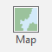
Note, this can also be done by navigating to All Apps followed by the ArcGIS Folder. Within the ArcGIS Folder, select ArcGIS Pro.
- Create a project to host your maps by clicking on the Map icon.
- The Create a New Project window should be shown. Define the name for your project as ‘Lab01’. Then click on Folder icon, find the location where you want to save your project.
- You do not need to change others.
- Click on OK.

Step 2. Create a Feature Dataset

You will use Catalog to create a new network dataset. To achieve that, you will need to create a feature dataset to store your road layer.
- Click on Catalog Pane under View Tab.
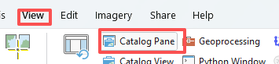
- In the Catalog window, expand the Folders. Your project folder should be shown.
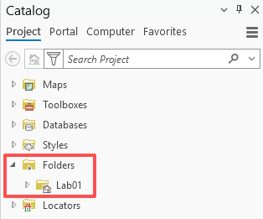
- Expand the project folder, there is a geodatabase associated with it. You will create a feature dataset under the geodatabase.
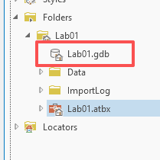
- Right-click on the geodatabase (e.g., Lab01.gdb in my case), in the drop-down menu, select New followed by Feature Dataset.

- In the Create Feature Dataset window, set Feature Dataset Name to ‘Transportation’.
- Set Coordinate System to ‘NAD 1983 UTM Zone 18N’ by clicking on the earth icon . In the Coordinate System window, expand Projected Coordinate System, followed by UTM, NAD 1983, and NAD 1983 UTM Zone 18N. We set this projection as it is the same as the data.
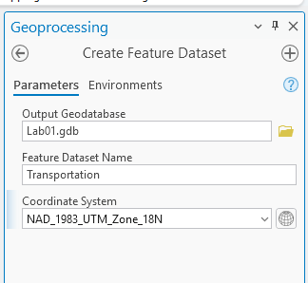
- Click Run.

Now you will need to import the NewYork_roads layer to the feature dataset.
- Expand the geodatabase, the feature dataset you just created should be shown.
- Right click on Transportation, in the drop-down menu, select Import, followed by Feature Class(es).
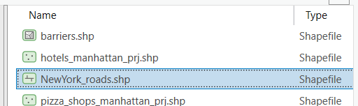
- In the Feature Class To Geodatabase window, set Input Features as “NewYork_roads”. You will need to click on the folder icon , navigate to your data folder, highlight NewYork_roads.shp and click on OK.
- Click on Run.
Expand Transportation feature dataset, the NewYork_roads should be shown.
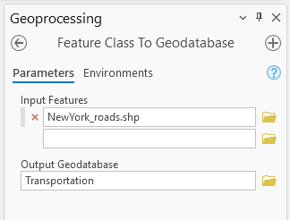
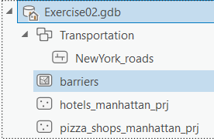
Using similar method, import hotels_manhattan_prj, pizza_shops_manhattan_prj, and barriers into your geodatabase. Note, you do not need to import the three layers into the Transportation feature dataset. Your imported data should look like the right-side figure.

Deliverable 1. Screenshot your geodatabase showing the imported data layers. (5 Points)
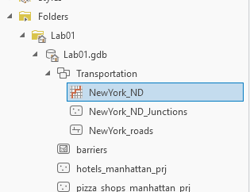

Step 3. Create a Network Dataset

Before creating a new network dataset, we will learn more about the fields or attributes in NewYork_roads layer.
- Right-click on NewYork_roads under Transportation feature dataset. In the drop-down menu, select Add to Current Map.
- In the Contents Pane, the NewYork_raods should be shown.
- Right-click on NewYork_roads layer under Contents Pane, in the drop-down menu, select Attribute Table.
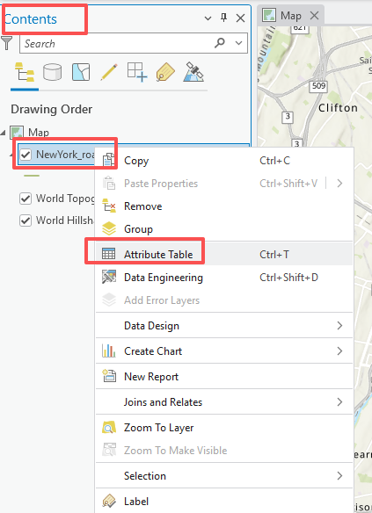
- The RD_length and RD_time attributes represent the length of each street segment and the time needed to travel along each segment under the speed limit, respectively. The unit for RD_length and RD_time is mile and minutes, respectively. These two fields will be used as cost attributes. Please kind this in mind.

Now, you are ready to create the network dataset.
- Right-click on Transportation feature dataset in the Catalog Pane. In the drop-down menu, select New, followed by Network Dataset.
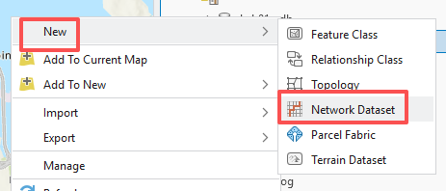
- In the Create Network Dataset, set Network Dataset Name as “NewYork_ND”; check the box before NewYork_roads under Source Feature Classes; set Elevation Model as “Elevation fields”.
- Click on Run.
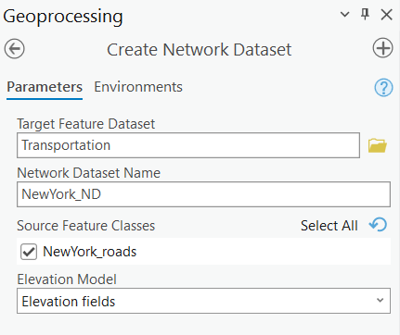

After finishing, you should see NewYork_ND and NewYork_ND_Junctions under Transportation feature dataset in the Catalog Pane. The NewYork_ND is also automatically added to the Contents Pane.

- Remove the NewYork_ND in the Content Pane by right-clicking on it, followed by Remove.
We remove the NewYork_ND as it is not fully set up yet, you need to adjust the connectivity.
- In the Catalog, right-click on NewYork_ND, in the drop-down menu, select Properties.
- In the NewYork_ND properties window, click on Travel Attributes, followed by Costs.
- There is a default distance cost, called length, which is measured by meters. Under the Properties panel, change units to “miles”, change Data Type to “float”, to be consistent with RD_length field.
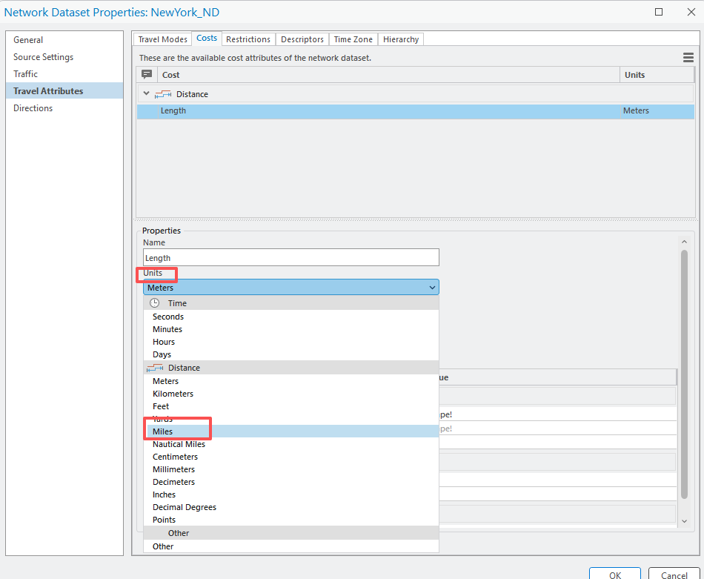
- Under the Evaluators panel, Set Type as “Field Script” for NewYork_roads (Along) by clicking on that, in the drop-down menu, select “Filed Script”. This may be the default. Double-click the Value, the Evaluator Settings Button should be shown.
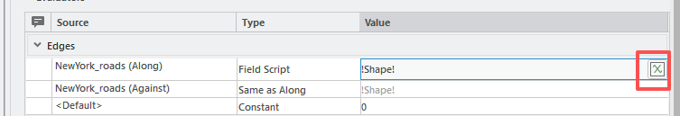
- Click on this button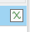, in the Field Script window, set Value as “ [RD_length]”.
- Click on OK.
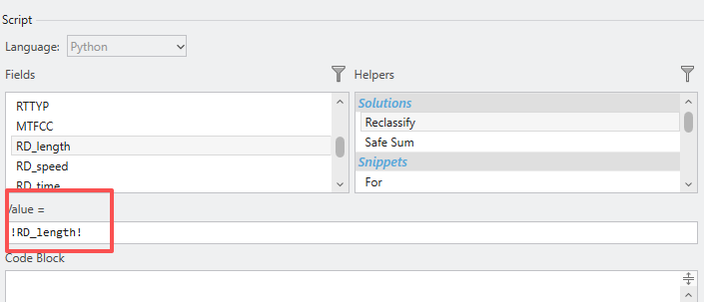

Now, you will add the cost of time.
- Click on the expansion icon at right-top corner, in the drop-down menu, select New.
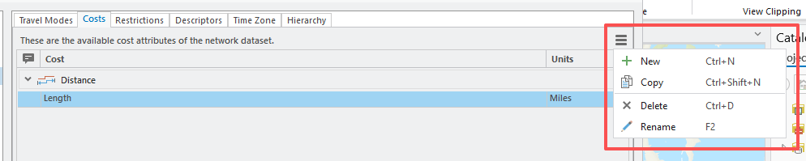
- Under the Properties panel, set Name as “Time”, Unit as “Minutes”.
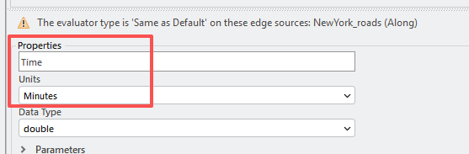
- Under the Evaluators panel, Set Type as “Field Script” for NewYork_roads (Along) by clicking on that, in the drop-down menu, select “Filed Script”. Double-click the Value, the Evaluator Settings Button should be shown. Click on this button, in the Field Script window, set Result as “[RD_time]”.

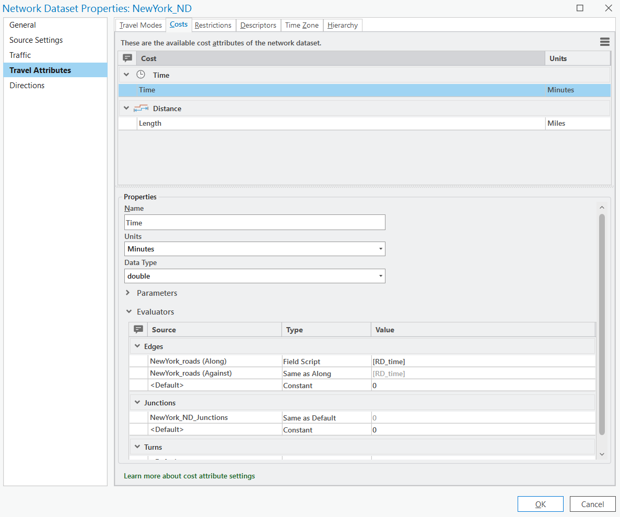
In your network, you would like to model both the travel distance and time. That is why you are defining these attributes. Now you will create travel mode based on distance and time, respectively.
- Click on Travel Modes Tab, followed by the expansion icon.
- In the drop-down window, select New.
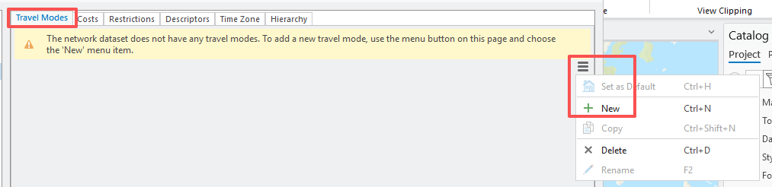
- Change New Travel Mode to “Distance_mode” by typing it. Set Type to “Driving”.
- In the Costs panel, set Impedance to “Length”, Time cost to “Time”, and Distance Cost to “Length”.
- Make sure U-Turn at Junctions is set to allow, this should be in default.
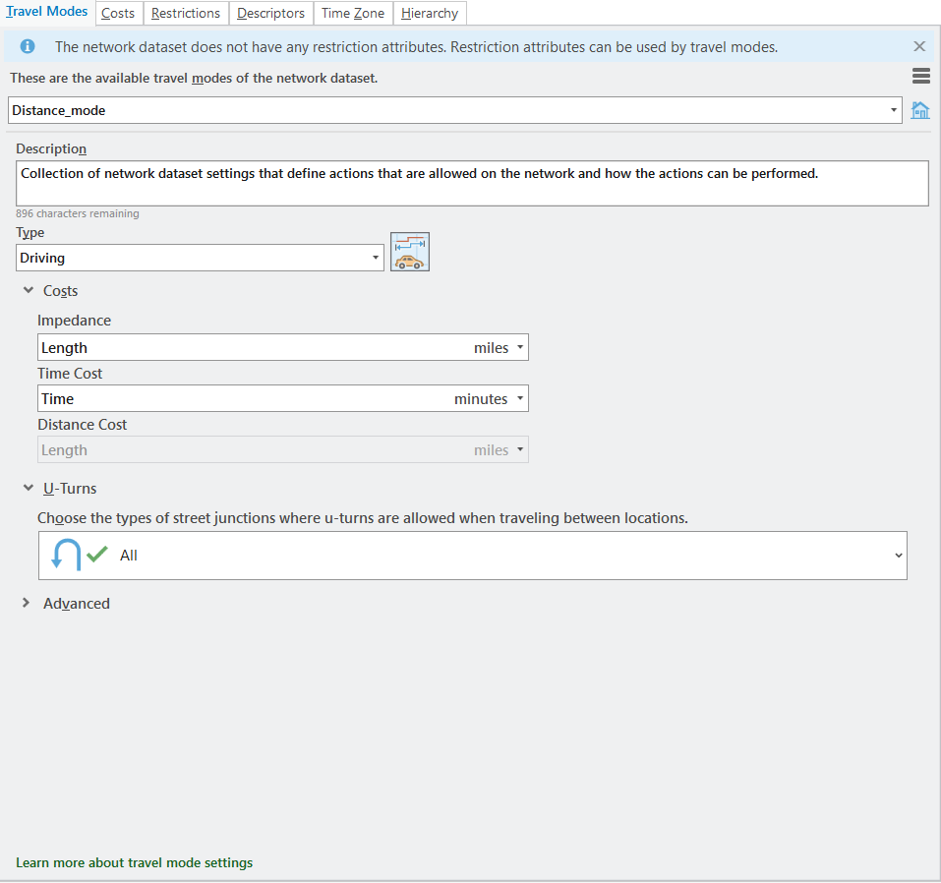

Use the same method, to create another Travel Mode.
- Click on the expansion icon.
- In the drop-down window, select New.
- Change New Travel Mode to “Time_mode” by typing it. Set Type to “Driving”.
- In the Costs panel, set Impedance to “Time”, Time cost to “Time”, and Distance Cost to “Length”.
- Make sure U-Turn at Junctions is set to allow, this should be in default.
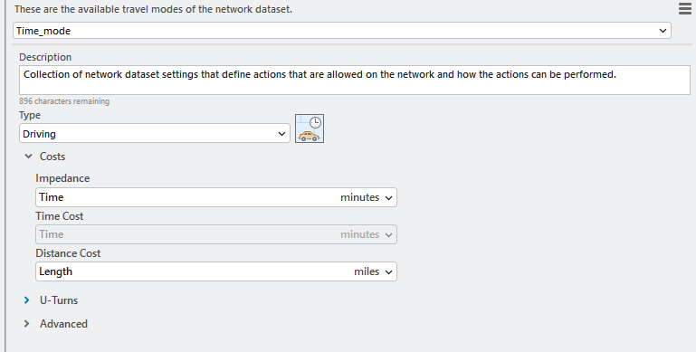

Deliverable 2. Screenshot your Travel Modes panel showing the Time_mode setting. (5 Points)
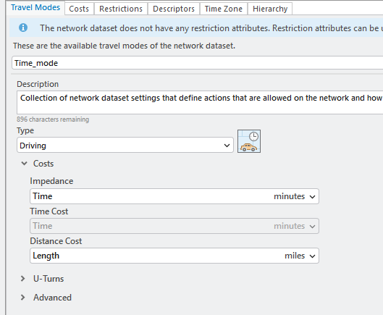
Now, you have fully set up two types of cost attributes in this network. You will need to re-build the network dataset.
- Click OK to exit the Properties window.
- In the Catalog Pane, righit-click on NewYork_ND, in the drop-down menu, select Build.
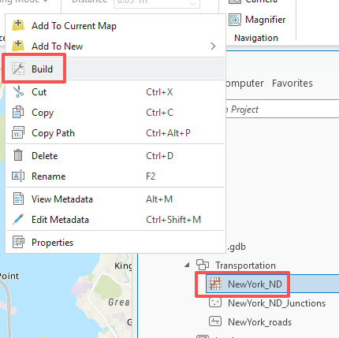
- In the Build Network window, make sure the Input Network Dataset is “NewYork_ND”.
- Click Run.

Step 4. Analyzing Routes

Now that you have a network dataset, you can start using it to conduct network analysis. We will begin with route analysis.

Assume you are a pizza delivery person and need to make a delivery from pizza shop of PizzArte to the hotel of Harlem Loft. Find the fastest route based on distance.

First, you will need to select the restaurant and hotel of interest from a larger dataset. You can do this using the Select by Attribute Tool. Start by selecting the pizza shop.

- Right-click on the pizza_shops_manhattan_prj layer, in the drop-down menu, select Add to Current Map.
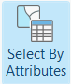
- Click on the Select by Attribute Tool in the Selection group under the Map Tab.
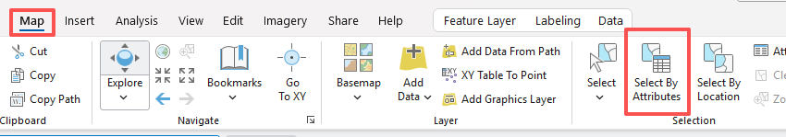
- Make sure the Input Rows is “pizza_shops_manhattan_prj” layer.

- Make sure the Selection Type is “New selection”.
- Create the following clause: “USER_Busin” is Equal to PizzArte.
- Click Apply.
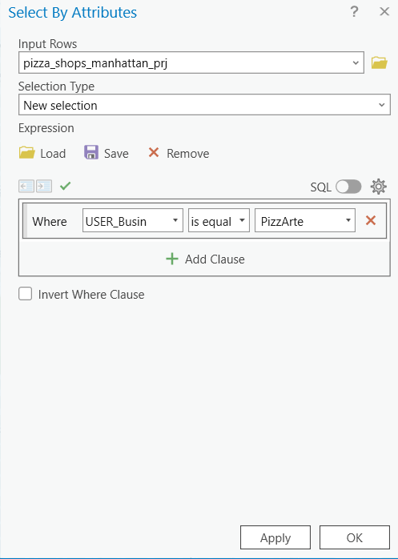

The PizzArte should be highlighted on the map.
- Right-click on the pizza_shops_manhattan_prj layer in the Contents Pane, in the drop-down menu, select Data, followed by Export Features.
- In the Export Features window, make sure the Input Features is pizza_shops_manhattan_prj. Set the Output Feature Class as “PizzArte”.
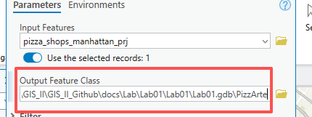
- Click on OK.

The PizzArte layer should automatically add to the Contents Pane. Click on Clear icon in the Selection Group under Map Tab to clear the selection.
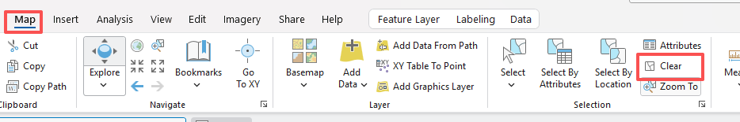
Use the same method to select Harlem Loft from hotels_manhattan_prj layer and export it as “Harlem_Loft”. Hint, the clause would be: “USER_Hotel” is Equal to Harlem Loft.

Deliverable 3. Screenshot your map only showing the Harlem Loft hotel and PizzaArte. (5 Points)
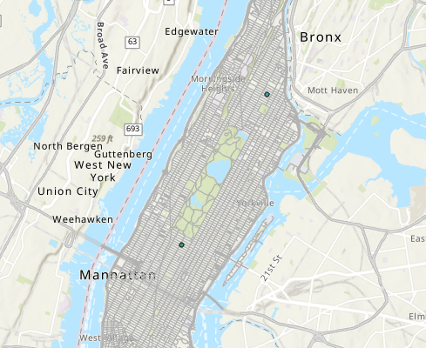
To see the results clearly, you want to
- Uncheck the box before all layers, except Harlem_Loft and PizzArte layers.

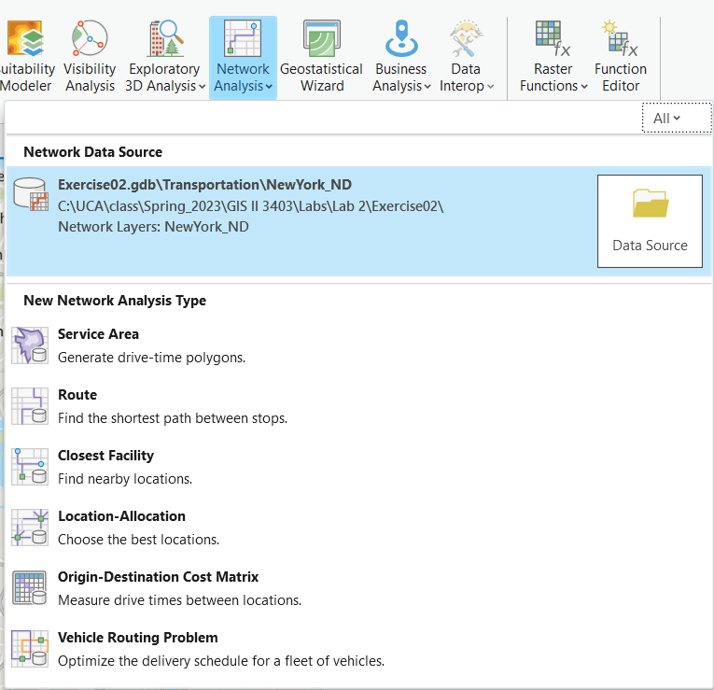
Now you have the required locations. You can begin setting up the route analysis.
- Navigate to the Analysis Tab. Click on Network Analysis followed by Route. This will generate a new Route Layer.
Note, make sure the Network Data Source is NewYork_ND that you just created. Otherwise, you need to click on the Folder icon to change it to NewYork_ND.

Wait for a while, a Route layer should be shown in the Contents Pane. At the top of the window, you could also see a Route Layer Tab.
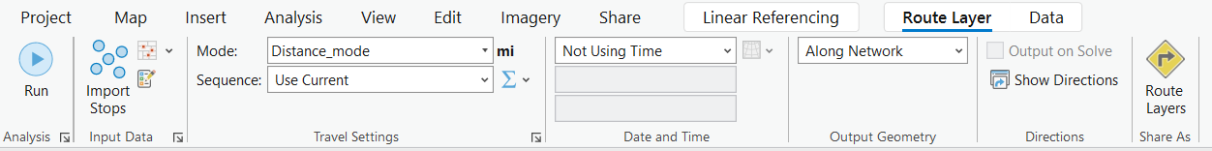

- Click on the Import Stops button under the Route Layer Tab.
- In the Add Locations window, set Input Network Analysis Layer as “Route” and Sub Layer as “Stops”.
- Se the Input locations to the PizzArte layer.
- You do not need to change others.
- Click on Apply to execute the tool.
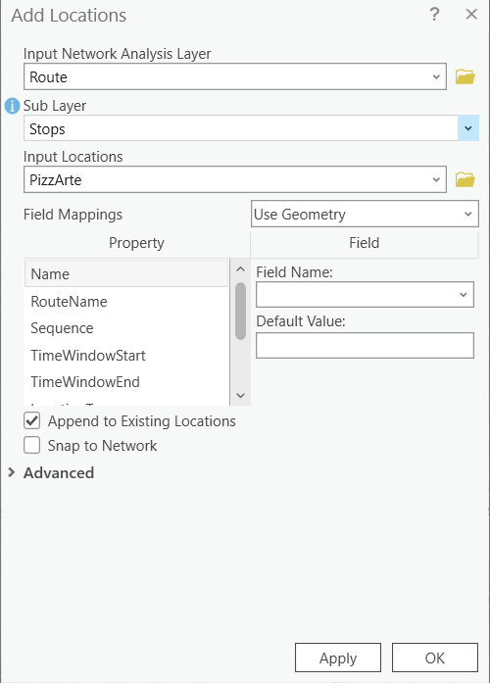

This will add the pizza shop as a stop.

Repeat the process to add the Harlem_Loft layer. Make sure that Append to Existing Location is selected in the Add Locations window.
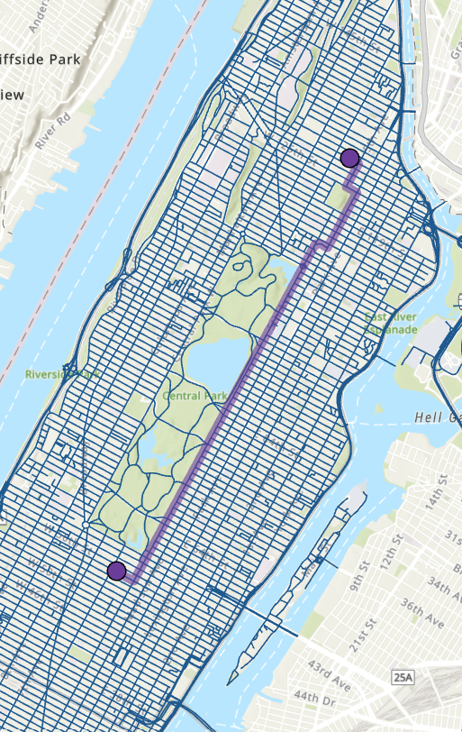
- Set Mode as “Distance_mode” in the Travel Settings group under the Route Layer Tab.
- Click on Run to perform the Analysis.
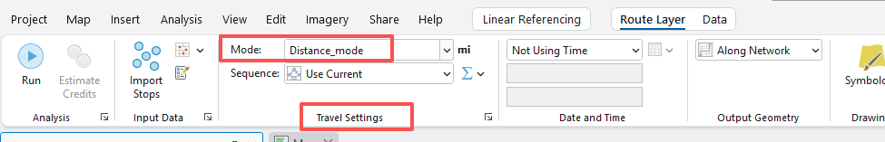
Wait for a while, after it finishes, a rout should be added to your map. This route is also added to the Routes sublayer in the Route layer in the Contents Pane. Right-click on this sublayer, in the drop-down menu, select the attribute table to answer the following questions.
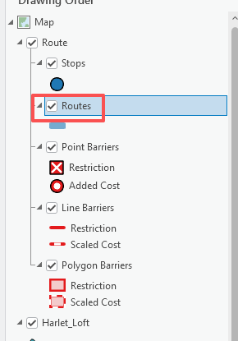

Question 1. What is the total distance for this route in miles? (2 Points) (Hint, the result is in “Total_Length” filed)
4.098
Question 2. What is the total travel time for this route in minutes? (2 Points) (Hint, the result is in “Total_Time” filed)

Now, instead, find the fastest route based on distance, you will find the fastest route from pizza shop of PizzArte to the hotel of Harlem Loft based on time.

- Set Mode as “Time_mode” in the Travel Settings group under the Route Layer Tab.
- Click on Run to perform the Analysis again.

Use the attribute table of Routes layer to answer the following questions.

Question 3. Did optimizing for time change the route? (2 Points)
Yes

Question 4. What is the total distance for this route in miles? (2 Points) (Hint, the result is in “Total_Length” filed)
5.73

Question 5. What is the total travel time for this route in minutes? (2 Points) (Hint, the result is in “Total_Time” filed)
7.54
It is also possible to input barrier features as lines or polygons to include in a network analysis. This could be useful for modeling detours or road closures. You will now conduct route analysis with barriers included. Note, this barrier layer is a conceptual layer, modeling the route closures due to the construction in a bridge in Manhattan.

- Right-click on the barriers layer in the Catalog, in the drop-down menu, select Add to Current Map.
- Navigate back to the Route Layer Tab.
- Click the Import Stops button in the Input Data group.
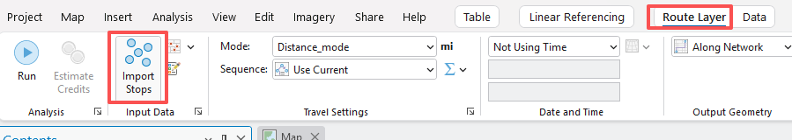
- In the Add Locations window, set Input Network Analysis Layer as “Route” and Sub Layer as “Polygon Barriers”.

- Se the Input locations to the “barriers” layer.
- You do not need to change others.
- Click on Apply to execute the tool.
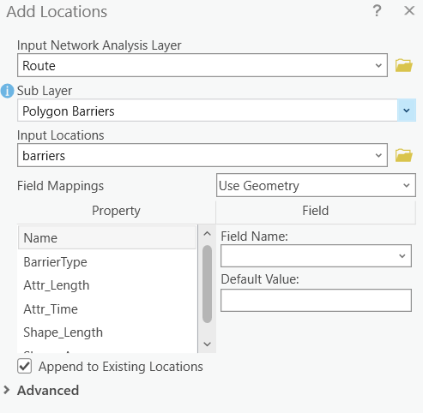

You are now ready to re-execute the tool.

- Set Mode as “Distance_mode” in the Travel Settings group under the Route Layer Tab.
- Click on Run.

Deliverable 4. Screenshot your map showing the route considering the barriers. (5 Points)
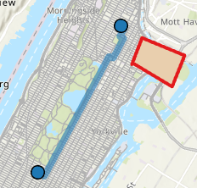

Question 6. What is the total distance for this route in miles? (2 Points) (Hint, the result is in the “Total_Length” filed)
4.09
- Set Mode as “Time_mode” in the Travel Settings group under the Route Layer Tab.
- Click on Run.

Question 7. What is the total travel time for this route in minutes? (2 Points) (Hint, the result is in “Total_Time” filed)
9.22

Question 8. How much longer will this route take in minutes in comparison the route optimized for time that did not include the barriers? (2 points) (Hint, do the comparison with Question 5)
9.22-7.54

Step 5. Analyzing Service Areas

You will now explore service areas. You can define service areas based on distance or travel time. You will explore both options here.

- Navigate to the Network Analysis Tab again. In the drop-down menu, select Service Area.
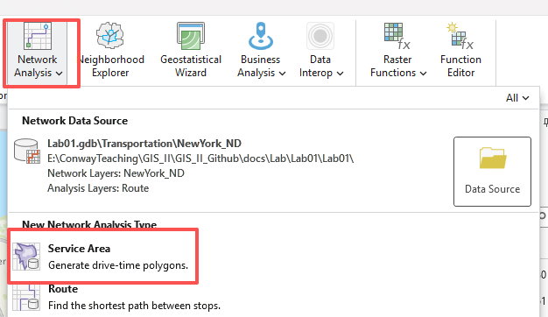
- A new Service Area Layer should be added to the Contents Pane.

Note, the Service Area Tab will only be available when the Service Area layer in the Contents Pane is Highlighted.

Now, you will find all of the areas that are within 10 miles of a pizza shop and determine how many hotels are outside of this travel distance.

- Click on the Import Facilities icon in the Input Data group under the Service Area Tab.
- In the Add Locations Tool, set the Input Network Analysis Layer as “Service Area” layer, and Sub Layer as “Facilities”.
- Set the Input Locations to the “pizza_shops_manhattan_prj” layer.
- You do not need to change any additional settings.
- Click Apply to execute the Tool.
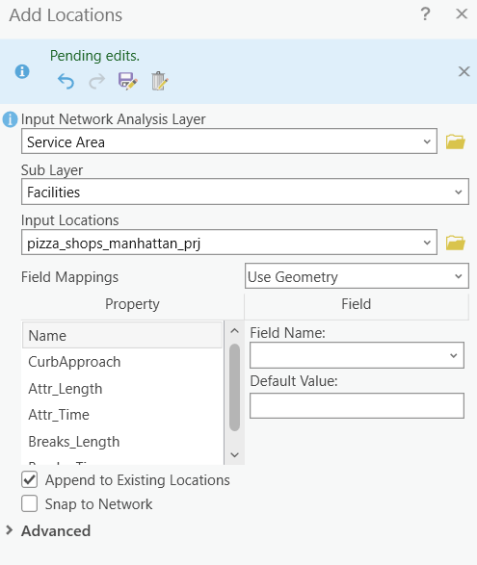

To read the results clearly, you can turn off other layers.

- Set Mode as “Distance_mode” in the Travel Settings group under the Route Layer Tab.
- Set the Direction as “Away from Facilities”.
- Change the cutoffs to 10.
- Click on Run.
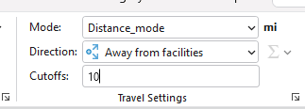

Turn on the hotels_manhattan_prj layer, and answer the following questions.

Question 9. How many of the mapped hotels were not within 10 miles along the road network to one of the mapped pizza shops (2 Points) (Hint, count the hotels that are not in the shaded area)
0
Now you want to find the areas that are within 5 minutes travel time of a pizza shop and determine how many hotels are outside of this travel time.

- Set Mode as “Time_mode” in the Travel Settings group under the Service Area Layer Tab.
- Set the Direction as “Away from Facilities”.
- Change the cutoffs to 5.
- Click on Run.

Question 10. How many of the mapped hotels were not within 5 minutes along the road network to one of the mapped pizza shops (2 Points) (Hint, count the hotels that are not in the shaded area)
1

Step 6. Analyzing Closest Facility

Now, you will explore the closest facility to determine what pizza shop is closest to each hotel.

- Navigate to the Network Analysis Tab again. In the drop-down menu, select Closest Facility.
- A new Closest Facility Layer should be added to the Contents Pane.

Note, the Closest Facility Tab will only be available when the Closest Facility layer in the Contents Pane is Highlighted.

- Click on the Import Facilities icon in the Input Data group under the Closest Facility Tab.
- In the Add Locations Tool, set the Input Network Analysis Layer as “Closest Facility” layer, and Sub Layer as “Facilities”.
- Set the Input Locations to the “pizza_shops_manhattan_prj” layer.
- You do not need to change any additional settings.
- Click Apply to execute the Tool.
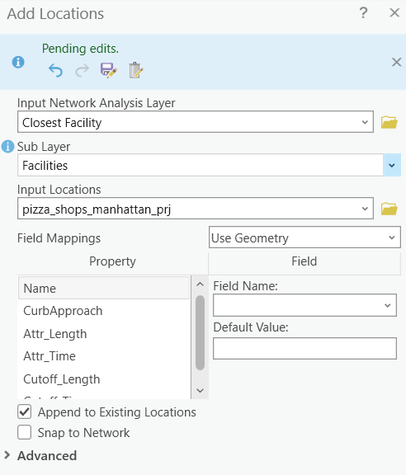

Again, to read the results clearly, you can turn off other layers.

You now need to import the incidences, in this case, the hotels.
- Click on the Import Incidences icon in the Input Data group under the Closest Facility Tab.
- In the Add Locations Tool, set the Input Network Analysis Layer as “Closest Facility” layer, and Sub Layer as “Incidents”.
- Set the Input Locations to the “hotels_manhattan_prj” layer.
- You do not need to change any additional settings.
- Click Apply to execute the Tool.

You will run this tool optimized for distance.
- Set Mode as “Distance_mode” in the Travel Settings group under the Closest Facility Tab.
- Make sure the Direction is “Towards Facilities”.
- Click on Run.

Use the result to answer the following question.

Question 11. Which pizza shop is closest to the Hotel of Conrad New York Downton? (3 Points) (Hint, you need to turn on the hotels_manhattan_prj and pizza_shops_manhattan_prj layers. You may also need to open the attribute tables of these two layers to find the name of hotels (in User_hotel field) and pizza shops (in User_Busi field))
Lombardi's

Step 7. Location-Allocation Analysis

Lastly, you will conduct a location-allocation analysis to determine which pizza shop is collectively nearest to all of the hotels based on travel distance and travel time.

- Navigate to the Network Analysis Tab again. In the drop-down menu, select Location-Allocation.
- A new Location-Allocation Layer should be added to the Contents Pane.

Note, the Location-Allocation Tab will only be available when the Location-Allocation layer in the Contents Pane is Highlighted.

- Click on the Import Facilities icon in the Input Data group under the Location-Allocation Tab.
- In the Add Locations Tool, set the Input Network Analysis Layer as “Location-Allocation” layer, and Sub Layer as “Facilities”.
- Set the Input Locations to the “pizza_shops_manhattan_prj” layer.
- You do not need to change any additional settings.
- Click Apply to execute the Tool.

Again, to read the results clearly, you can turn off other layers.

Next, you will need to import the hotels as the demand points.

- Click on the Import Demand Points icon in the Input Data group under the Location-Allocation Tab.
- In the Add Locations Tool, set the Input Network Analysis Layer as “Location-Allocation” layer, and Sub Layer as “Demand Points”.
- Set the Input Locations to the “hotels_manhattan_prj” layer.
- You do not need to change any additional settings.
- Click Apply to execute the Tool.

You will run this tool optimized for distance.
- Set Mode as “Distance_mode” in the Travel Settings group under the Location-Allocation Layer Tab.
- Make sure the Direction is “Away from Facilities”.
- Make sure the Facilities is set to 1.
- You do not need to change others.
- Click on Run.

Use the result to answer the following question.

Question 12. Which pizza shop is collectively nearest to all hotels based on travel distance? (2 Points) (Hint, you need to turn on the pizza_shops_manhattan_prj layers. You may also need to open the attribute tables of the layer to find the name of pizza shops (in User_Busi field))
Little Italy Pizza

Re-execute the analysis, but change the Mode to “Time_mode”.

Use the result to answer the following question.

Deliverable 5. Screenshot your map showing the pizza shop that is collectively nearest to all hotels based on travel time. (5 Points)
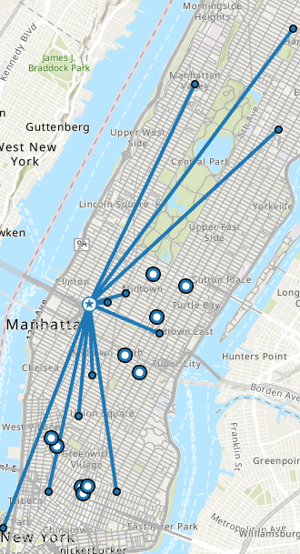

End of Exercise

Homework
Please submit a word file with 12 questions and 5 deliverables. Please submit through Blackboard.

